**DELHI PUBLIC SCHOOL**

**ASSIGNMENT NO. 1**

1. To make a 4*2 integer array of unsigned int16 and print shape, dimension and length of each element.

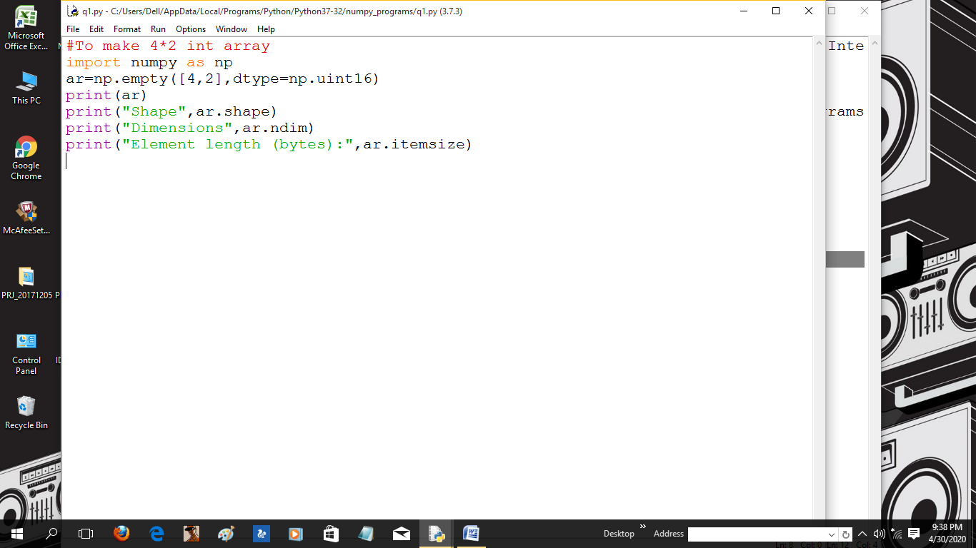

OUTPUT:

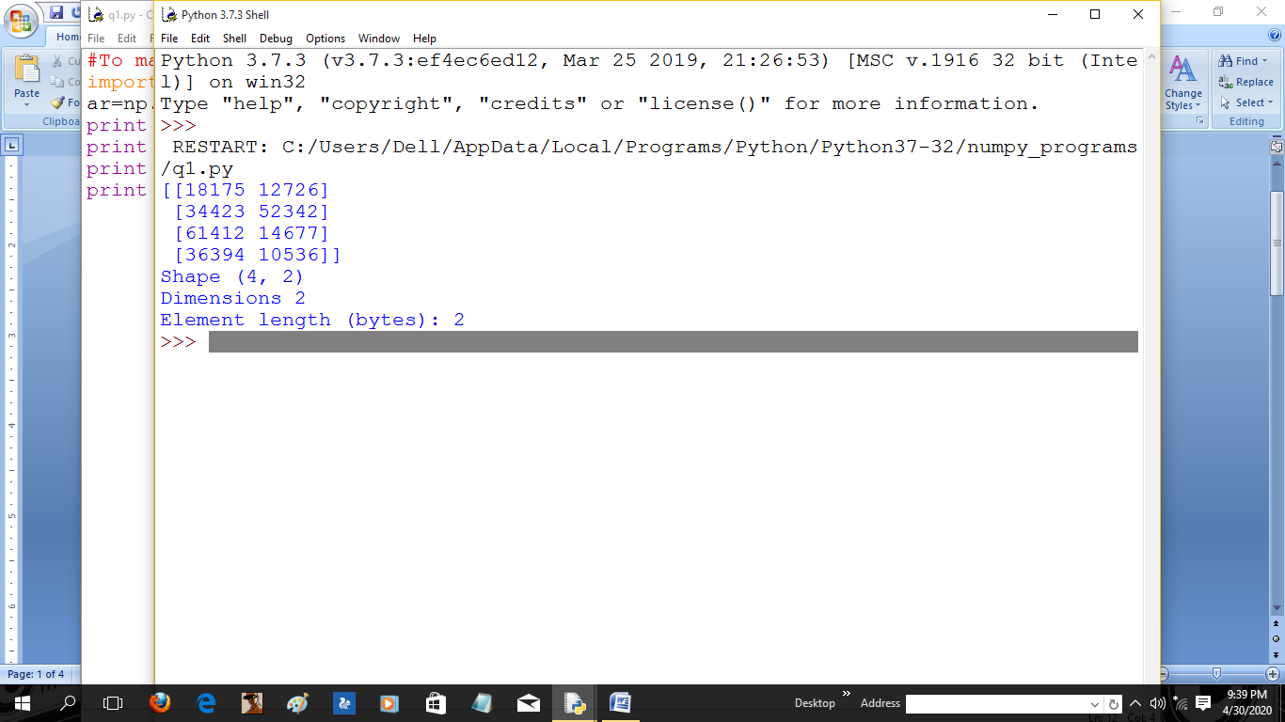

3. From a 3*3 numPy array return items in the second column from all rows. 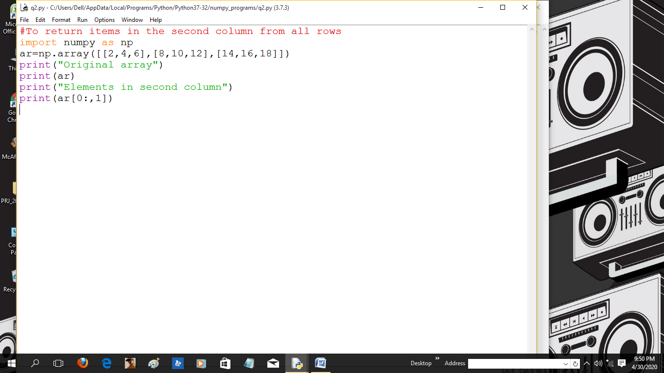

OUTPUT:

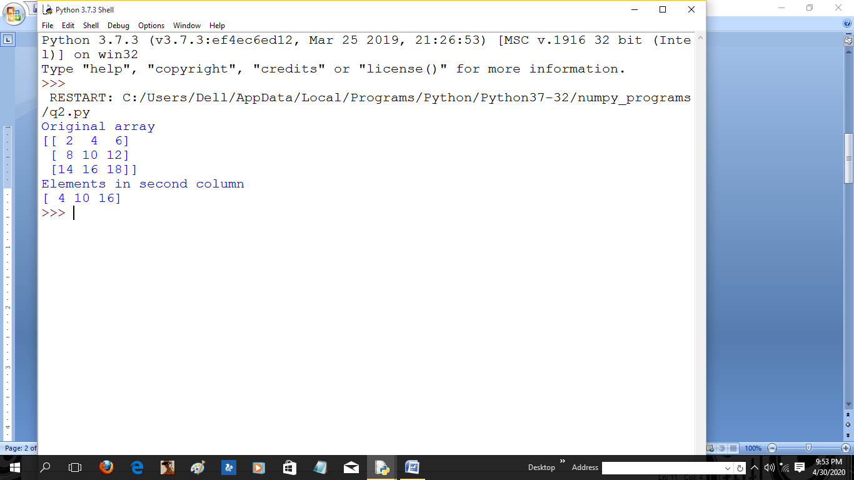

4. Extract odd rows and even columns from given numpy array.

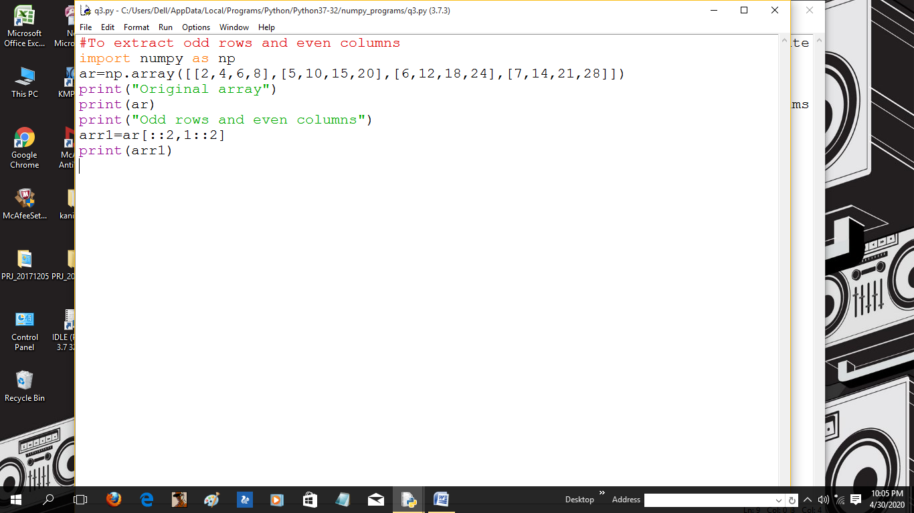

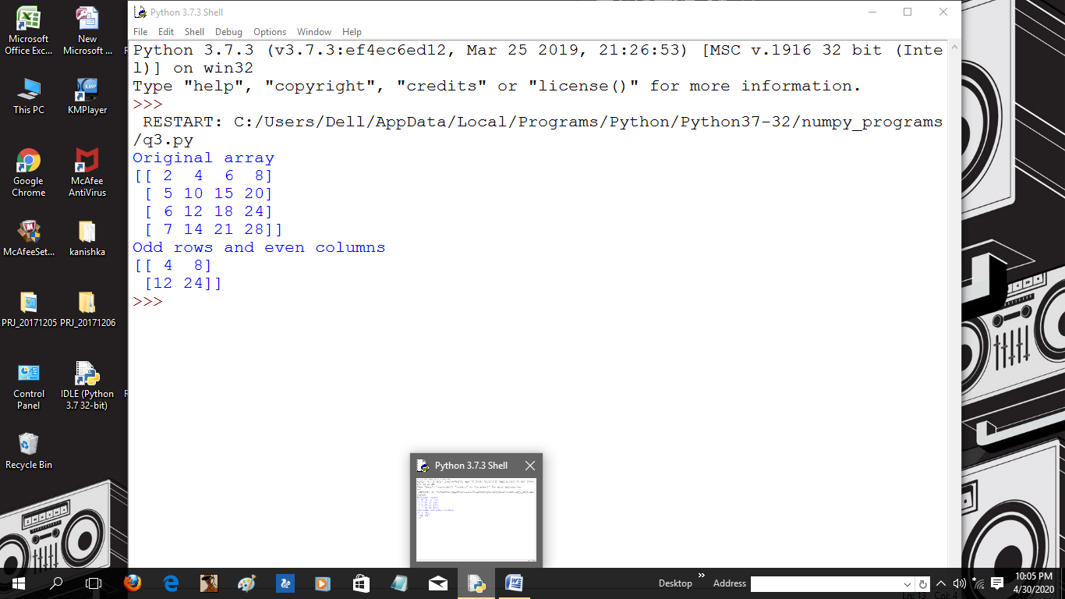OUTPUT:

5. Add the following two numpy arrays and in resultant array calculate the square of each number.

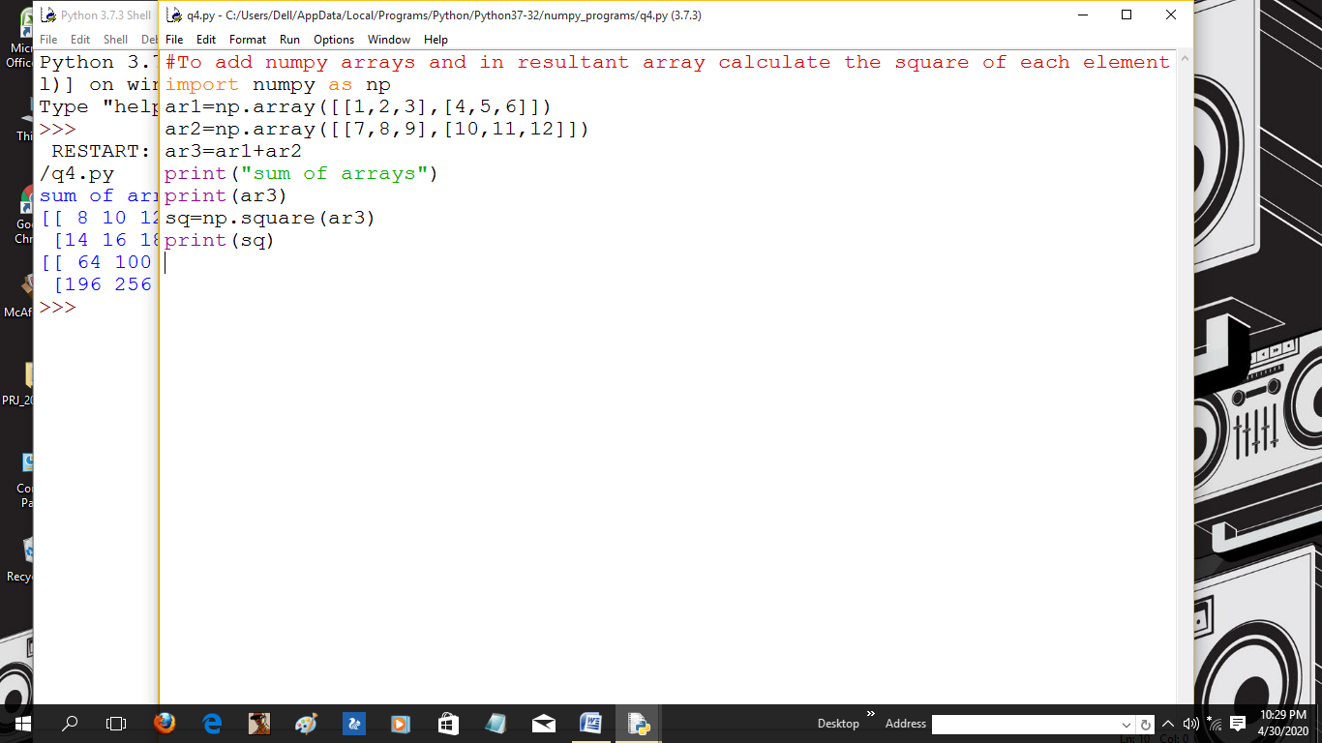

OUTPUT:

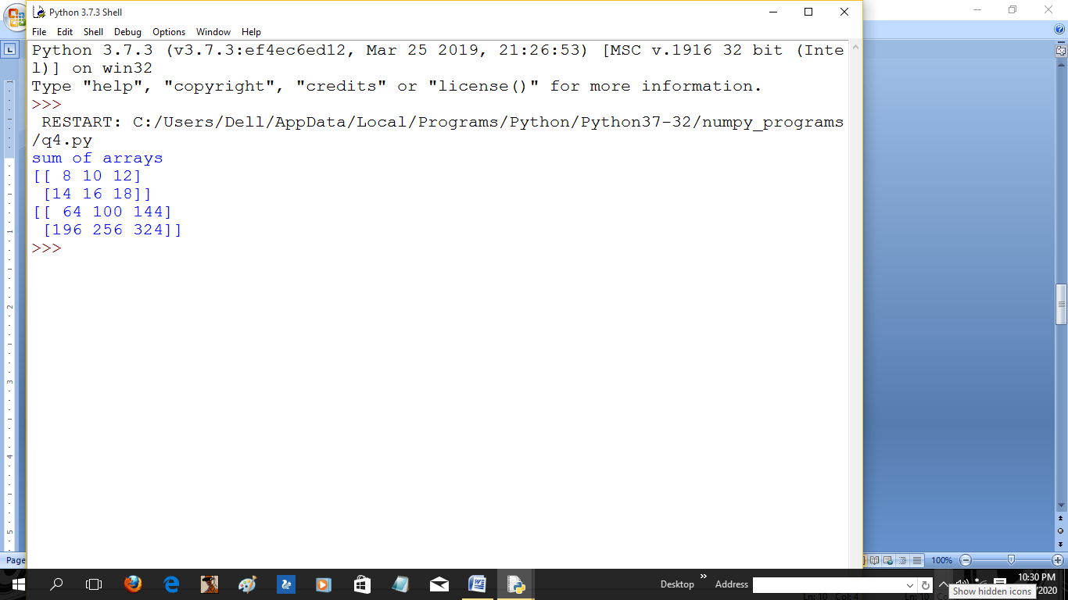

6. Create a 9*3 array from a range between 13 to 40 such that the difference between each element is 1 and then split the array into three equal sized sub-arrays.

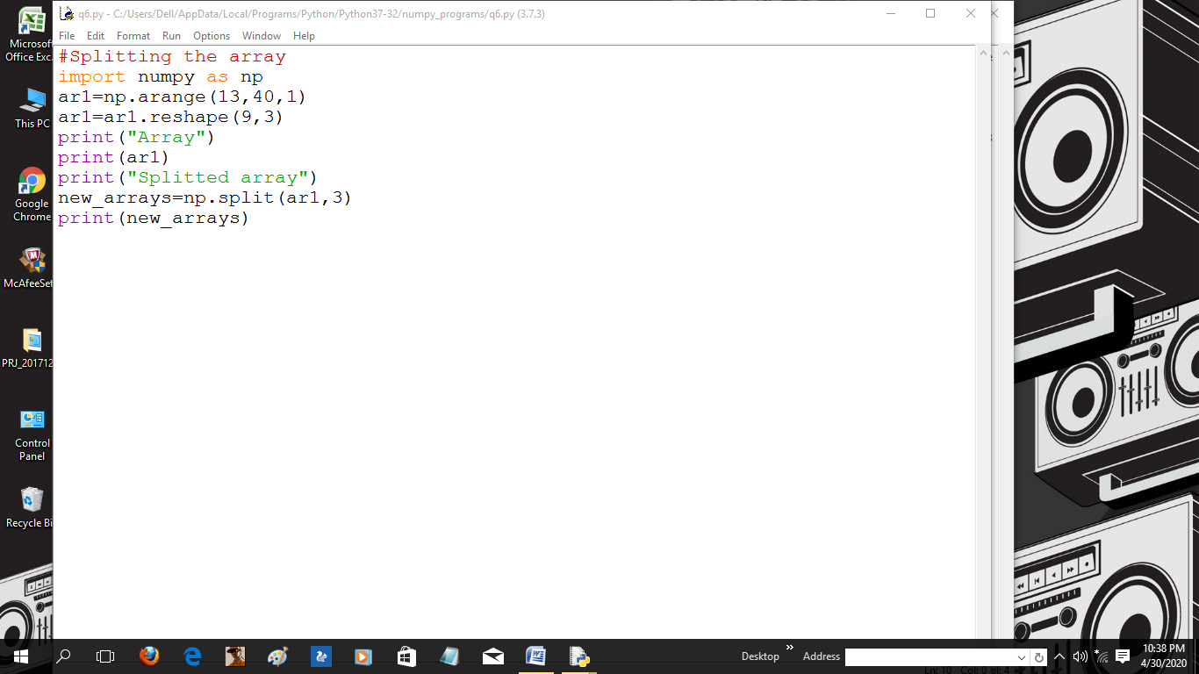

OUTPUT:

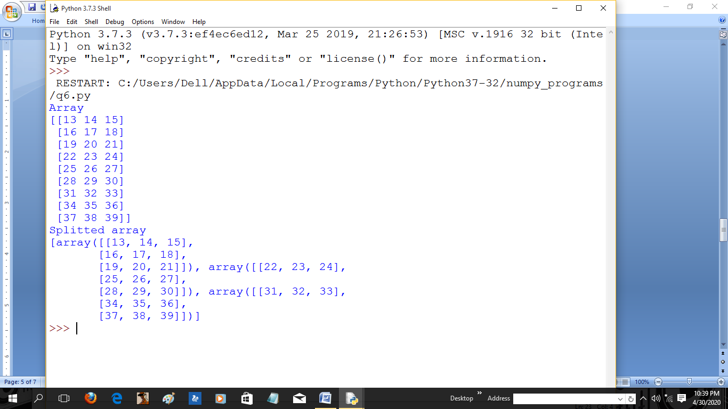

7. Sort the given numpy array:

* by second row

*by second column

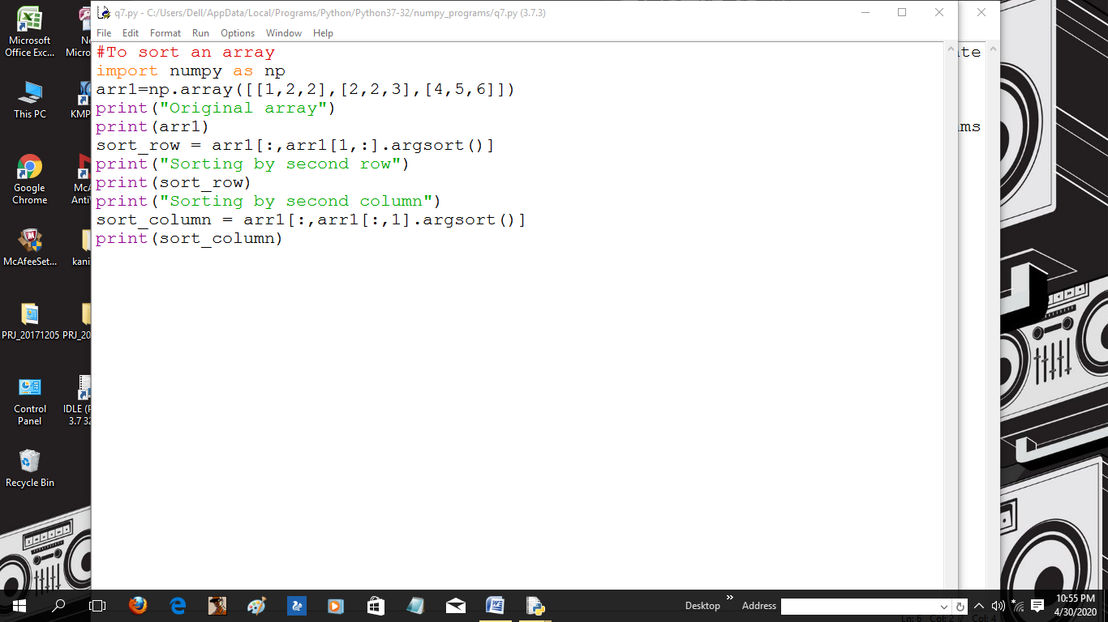

OUTPUT:

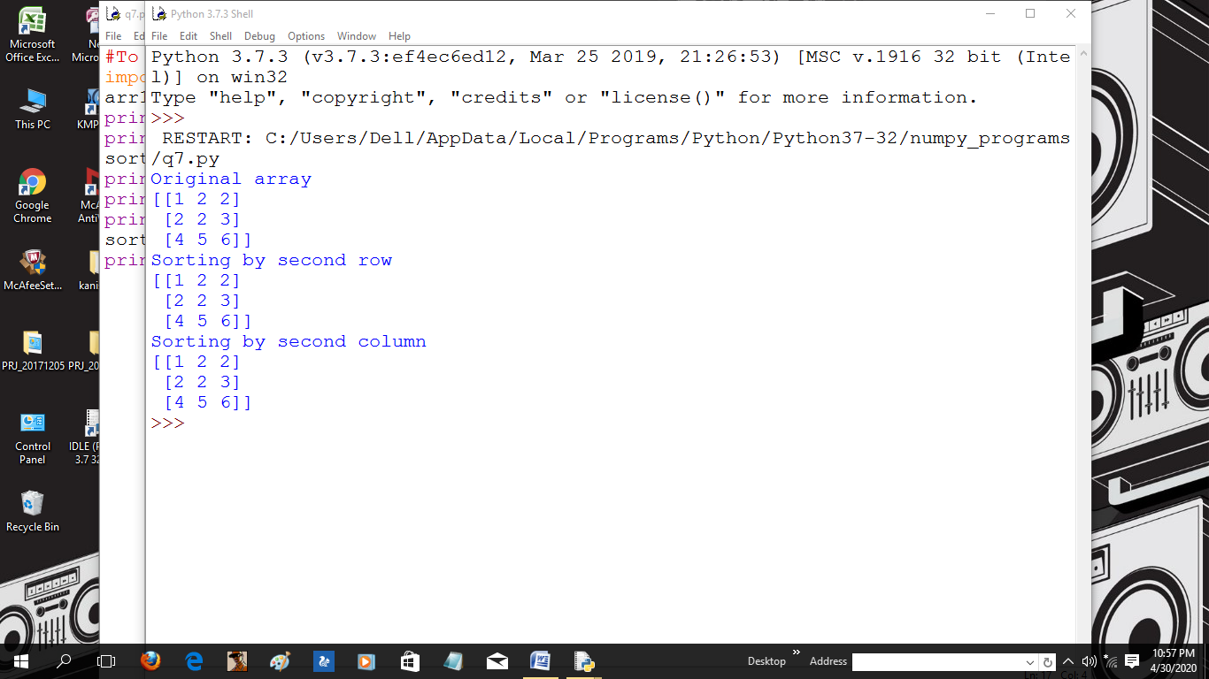

8. In a 2D numpy array print max from axis 0 and min from axis 1.

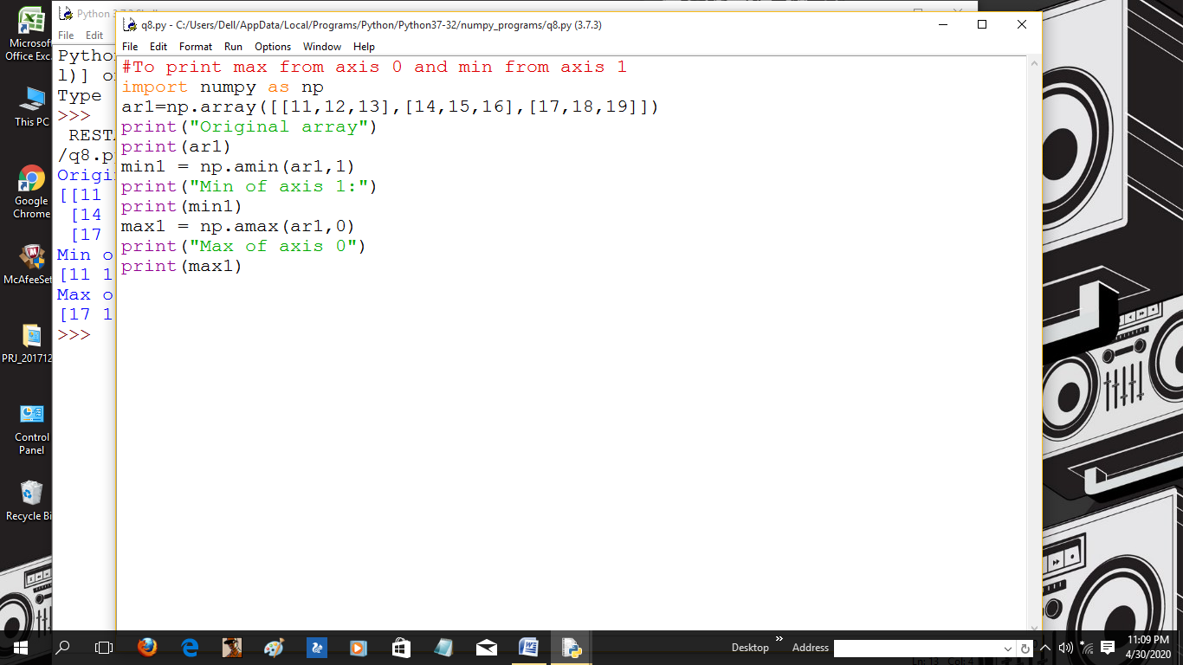

OUTPUT:

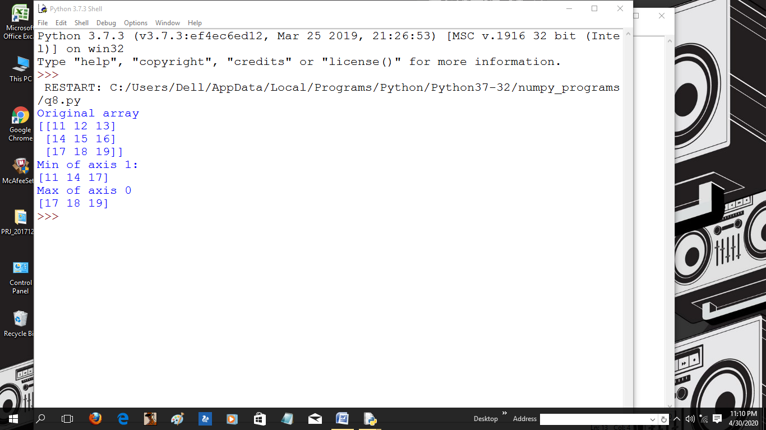

9. From a given numpy array delete second column and add a new column in its place.

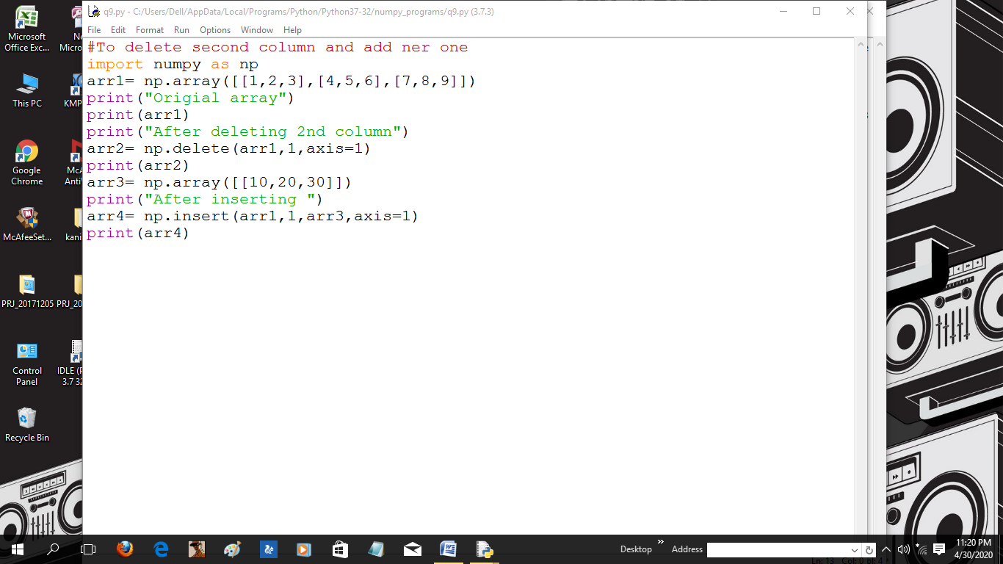

OUTPUT:

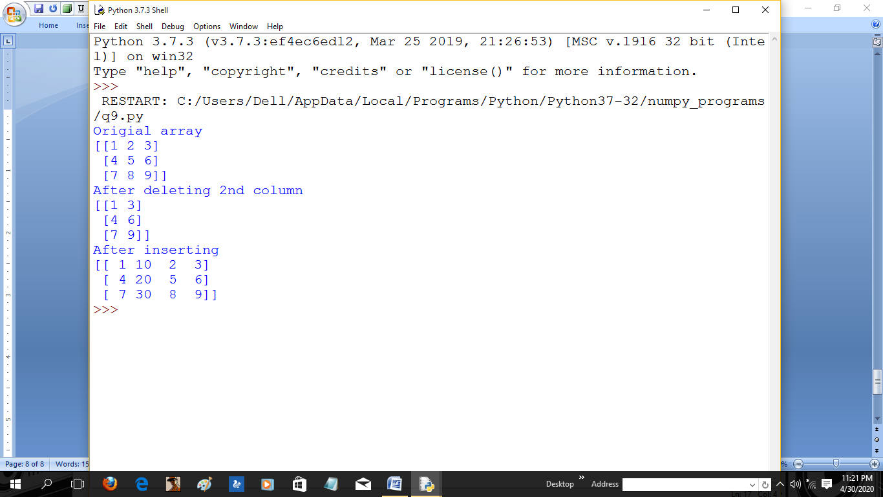

10. Find the position where elements of two numpy arrays x and y are same.

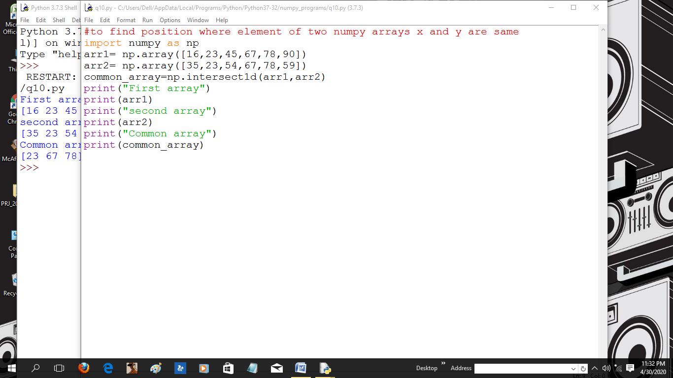

OUTPUT:

